BLESSING OVER MORGAN

Priest: Loving God, you created all the people of the world
and you know each of us by name. We thank you for Morgan, who today celebrates her fifteenth birthday.
Bless her with your love and friendship
that she may grow in wisdom, knowledge, and grace.
May she love her family always and be faithful to her friends. Grant this through Christ our Lord.

All: Amen.

BLESSING OVER ALL PRESENT

Priest: The Lord be with you. All: And with your spirit.

Priest: May almighty God bless you, the Father,
and the Son, and the Holy Spirit.

All: Amen.

DISMISSAL

Priest: Go in peace. All: Thanks be to God.

CLOSING SONG: “Sing to the Mountains,” #580

“Thank you for helping me celebrate my special day!”
Morgan Rae Pazdernik

Mi Quinceañera

August 14, 2021

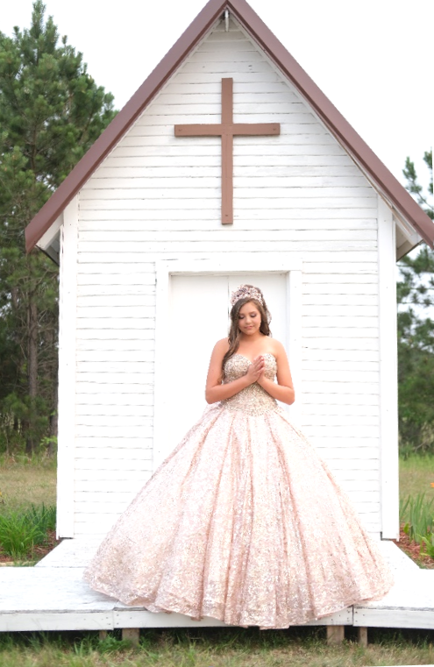

ENTRANCE SONG: “I Have Loved You,” #623

SIGN OF THE CROSS

Priest: In the name of the Father, and of the Son, and of the Holy Spirit.

All: Amen.

GREETING

Priest: The Lord be with you. All: And with your spirit.

PENITENTIAL ACT

Priest: Brothers and sisters, let us acknowledge our sins,
and so prepare ourselves to celebrate the sacred mysteries.

All: I confess to almighty God
and to you, my brothers and sisters,
that I have greatly sinned
in my thoughts and in my words,
in what I have done,
and in what I have failed to do;
through my fault, through my fault,
through my most grievous fault;
therefore I ask blessed Mary ever-Virgin,
all the Angels and Saints,
and you, my brothers and sisters,
to pray for me to the Lord our God.

Priest: May almighty God have mercy on us, forgive us our sins,
and bring us to everlasting life.

All: Amen.

Priest: Lord, have mercy. All: Lord, have mercy.

Priest: Christ, have mercy. All: Christ, have mercy.

Priest: Lord, have mercy. All: Christ, have mercy.

FLOWER TO MARY (at this time, Morgan will take a flower
or bouquet of flowers to a statue of the Blessed Mother)

Song: “Hail Mary, Gentle Woman,” #481

BLESSING OF RELIGIOUS ARTICLES

Bible and Rosary: One of the most important gifts given
to Morgan today is her Bible. Morgan can turn to her Bible
for companionship and advice all through her life.
This Bible was given to Morgan when she was in second grade
while attending St. Henry’s School.
The rosary is especially important in the Catholic faith.
This gift will assist Morgan with prayers of the Blessed Mother
and will strengthen her religious faith with God.

Ring: This ring is a gift that symbolizes the unconditional
and unending love and mercy of God. It is a circle of Morgan’s faith
and the passages that she will go through in life.

Earrings: The earrings are a gift to remind this beautiful young lady
to keep her ears in tune with the word of God as she turns into an adult.

Necklace: The necklace is a special gift worn close to her heart
and will remind Morgan to ALWAYS keep God in her heart
and a strong connection with Jesus Christ during her journey of faith.

Bracelet: This gift symbolizes God’s never-ending love;
one charm is a Christian symbol and one specifically is created
to remind her of this Quinceañera Mass.

Watch: The watch is an amazing gift to help remind Morgan
to make TIME for Jesus Christ every single day.

Lamb of God #204

Priest: Behold the Lamb of God, behold him
who takes away the sins of the world.
Blessed are those called to the supper of the Lamb.

All: Lord, I am not worthy that you should enter
under my roof, but only say the word
and my soul shall be healed.

Priest: The Body of Christ.

Communicant: Amen.

Communion Song: “One Bread, One Body,” # 793

PRAYER AFTER COMMUNION (Priest)

PRAYER OF DEDICATION (read by Morgan)

Heavenly Father, I thank you for the gift of life, for creating me
in your image and likeness, and for calling me
to be your daughter through Baptism.
Thank you for sending your Son Jesus to save me
and your Holy Spirit to sanctify me.
To that which in your goodness and love you will for me,
I say “yes,” with your grace I commit myself to serve my brothers
and sisters all my life.

Mary, Mother of Jesus and our Mother, I dedicate myself to you.
Since you are my model of faith, help me to continue learning
from you what I need to be a Christian woman.
Help me to hear the Word of God as you did, holding it in my heart
and loving others, so that, as I walk with Jesus in this life,
I may worship him with you in all eternity. Amen.

Priest: Morgan, may God, who has begun this good work in you,
bring it to completion.

(The Priest may sprinkle Morgan at this time with Holy Water)
COLLECT (after a period of silence, the Priest prays the Collect).

All respond: Amen.

LITURGY OF THE WORD

First Reading: Jeremiah 1:4-10 (read by Breck Hensch).

Lector: A reading from the book of the Prophet Jeremiah…
The word of the Lord.

All: Thanks be to God.

Responsorial Psalm: Psalm 16:1-2a and 5, 7-8, 11

Psalm response: You are my inheritance, O Lord.

Second Reading: Colossians 3:12-17 (read by Breck Hensch).

Lector: A reading from the letter of St. Paul to the Colossians…
The word of the Lord.

All: Thanks be to God.

Alleluia

Gospel: Matthew 19: 13-15

Priest: The Lord be with you.

All: And with your spirit.

Priest: A reading from the Holy Gospel according to Matthew.

All: Glory to you, O Lord.

Priest: The Gospel of the Lord.

All: Praise to you, Lord Jesus Christ.

Homily

General Intercessions

Lector: … We pray to the Lord.

All: Lord, hear our prayer.

(Father will conclude with a prayer)

LITURGY OF THE EUCHARIST

Song during the Presentation and Preparation of the Gifts:
“Here I Am, Lord,” #818

Priest: Pray, brothers and sisters, that my sacrifice
and yours may be acceptable to God the almighty Father.

All: May the Lord accept the sacrifice at your hands,
for the praise and glory of his name,
for our good and the good of all his holy Church.

Prayer over the Offerings… all respond “Amen.”

Preface:

Priest: The Lord be with you.

All: And with your spirit.

Priest: Lift up your hearts.

All: We lift them up to the Lord.

Priest: Let us give thanks to the Lord our God.

All: It is right and just.

Holy #199

THE EUCHARISTIC PRAYER

THE LORD’S PRAYER

All: Our Father, Who art in Heaven,
hallowed be Thy name; Thy Kingdom come, Thy will be done on earth as it is in Heaven. Give us this day our daily bread; and forgive us our trespasses as we forgive those
who trespass against us; and lead us not
into temptation, but deliver us from evil.

Priest: Deliver us, Lord, from every evil,
graciously grant peace in our days,
that, by the help of your mercy,
we may be always free from sin
and safe from all distress,
as we await the blessed hope
and the coming of our Savior, Jesus Christ.

All: For the kingdom, the power
and the glory are yours now and for ever.

Priest: Lord Jesus Christ, who said to your Apostles: Peace I leave you, my peace I give you;
look not on our sins, but on the faith
of your Church, and graciously grant her peace and unity in accordance with your will.
Who live and reign for ever and ever.

All: Amen.

SIGN OF PEACE

Priest: The peace of the Lord be with you always.

All: And with your spirit.

Priest: Let us offer each other the sign of peace.

